Cyber Security and Artificial Intelligence for Cloud- based Internet of Transportation Systems
In this project we have used Python DJANGO server as cloud server which act like intermediate between User and Autonomous Vehicle (AV). User will encrypt file using CPABE algorithm and then upload to Cloud and Cloud will upload to AV and then AV will update status as whether file received of not. Anytime user can connect to AV and download file. All files get encrypted using Public Key and decrypted using private key.
To implement this project we have designed two modules
- User Module: user can signup and login with the application and then transfer encrypted file to cloud to AV and then can view upload status and can download file
- Cloud Server: cloud server received file from user and then upload to AV
- AV: AV can login to system using username and password as ‘admin’ and ‘admin’ and then can view list of received files from various users or senders. All files will be saved at AV in encrypted format.
In below screen we are showing code for CPABE encryption
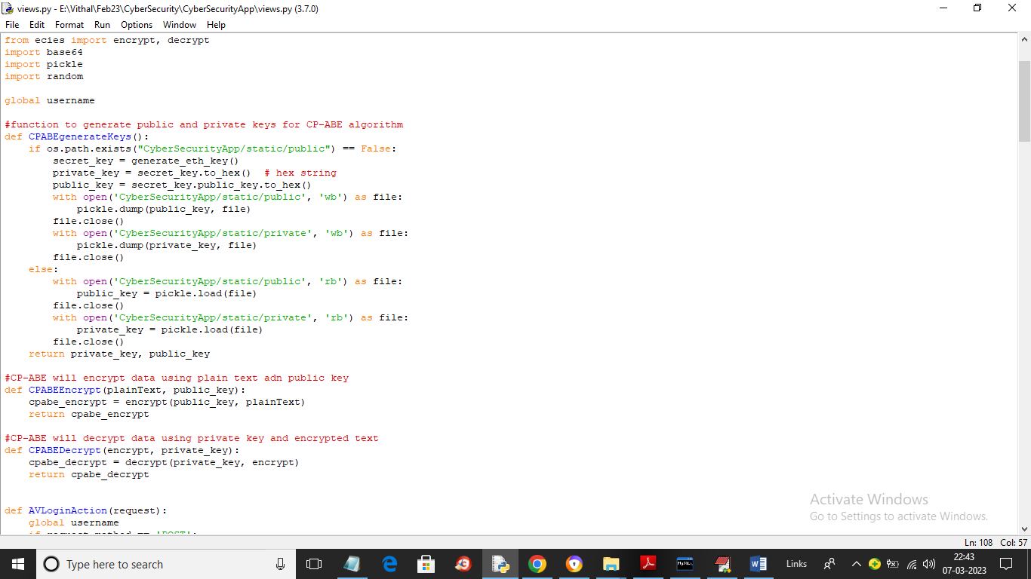
In above screen read red colour comments to know about CPABE key generation, encryption and decryption
To run project install MYSQL and then give password as ‘root’ and then open MYSQL console and copy content from ‘DB.txt’ file and then paste in MYSQL console to create database.
Now double click on ‘run.bat’ file to start DJANGO cloud server and get below screen
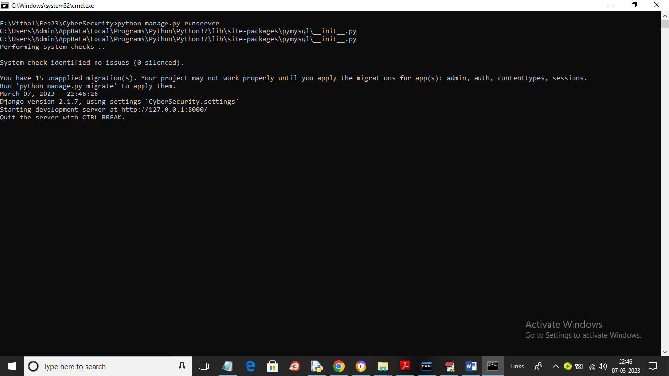
In above screen python Cloud Server started and now open browser and enter URL as http://127.0.0.1:8000/index.html and press enter key to get below page
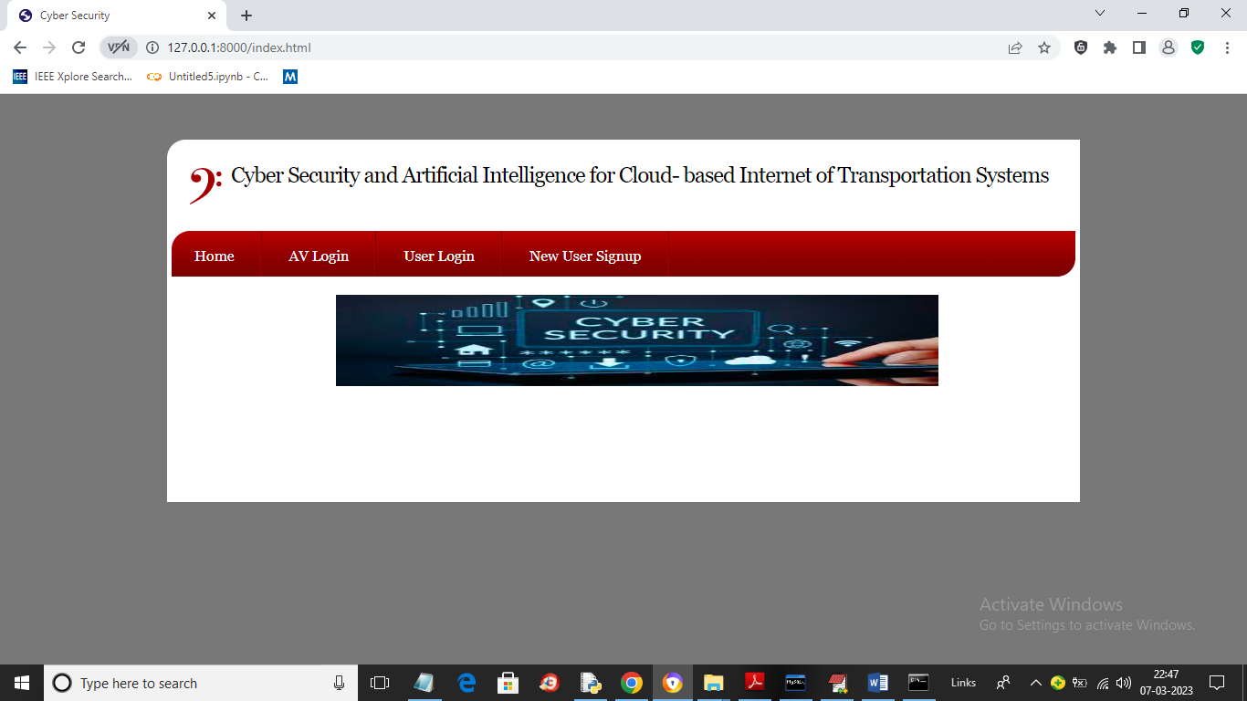
In above screen click on ‘New User Signup’ link to get below signup page and get below page
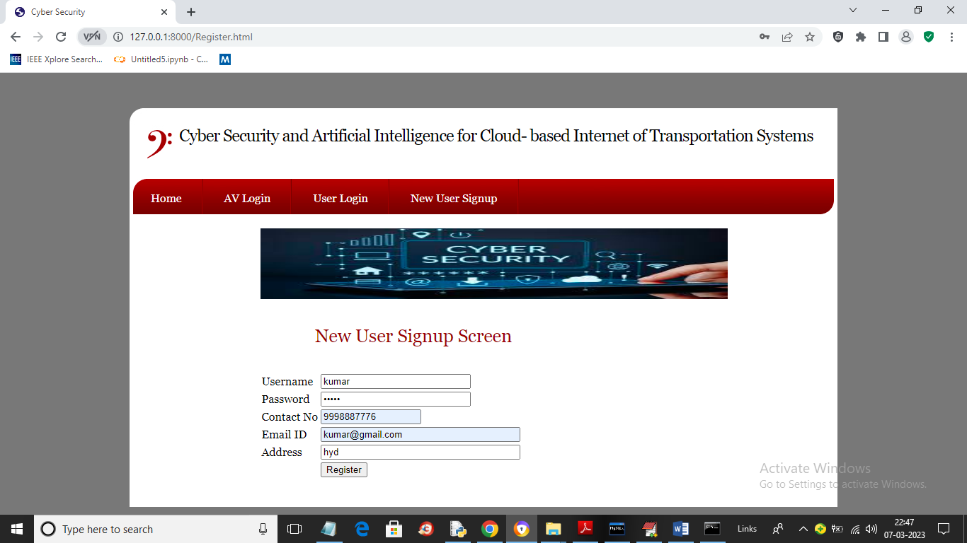
In above screen user is signup and now click on ‘Register’ button to get below page
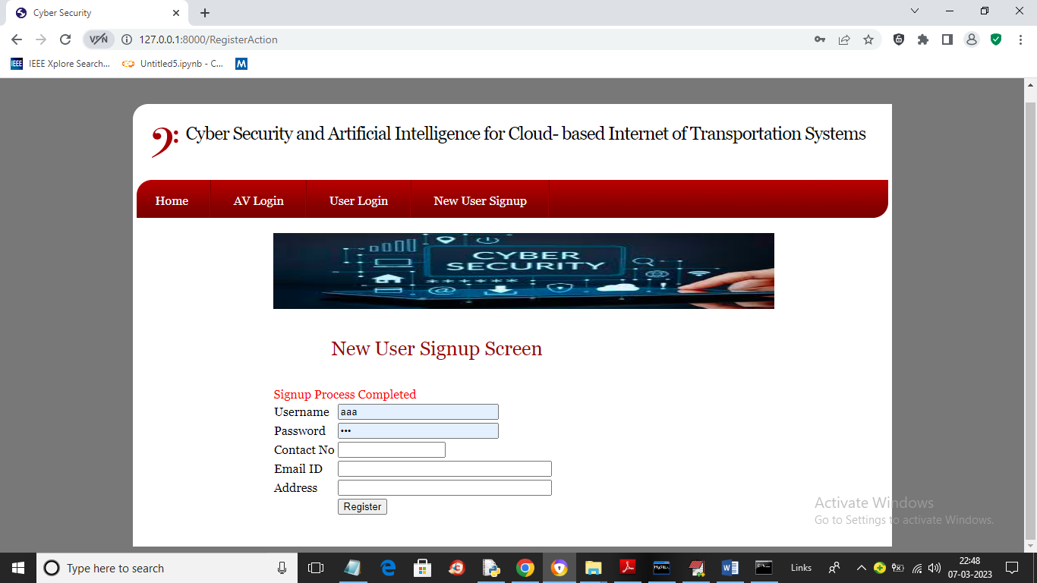
In above screen signup process completed and now click on ‘User Login’ link to get below page
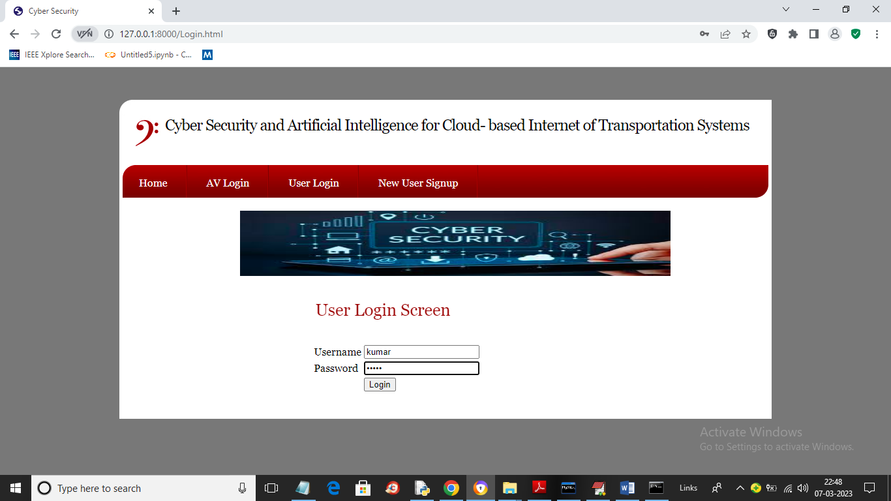
In above screen user is login and after login will get below page
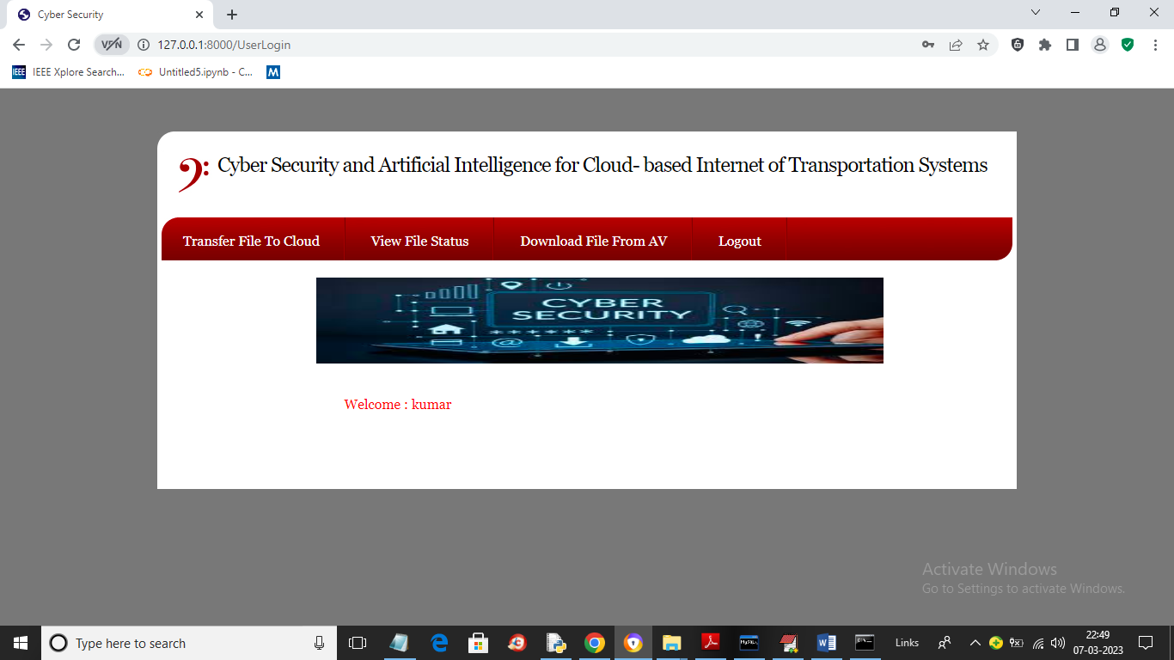
In above screen click on ‘Transfer File to Cloud’ link to upload file to cloud to AV and get below output
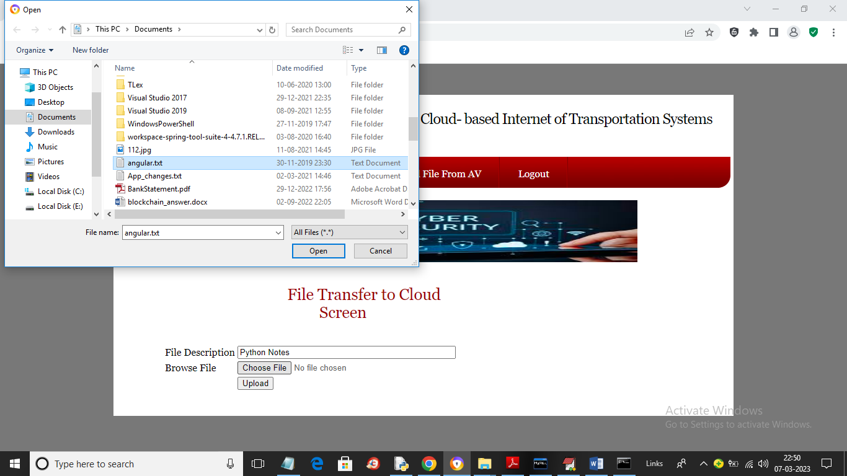
In above screen first enter some file description and then upload file and then click on ‘Open’ and ‘Upload’ button to send file to cloud to AV and get below page
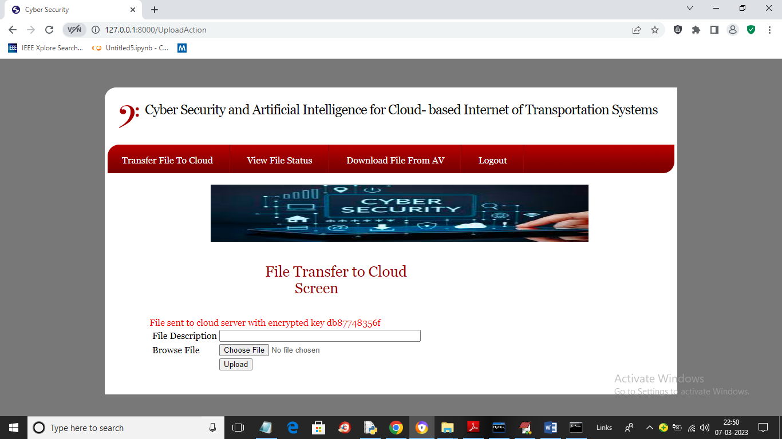
In above screen in red colour text we can see file is uploaded and we can see generated encrypted key also and in ‘CloudSecurityApp/static/Upload’ folder and we can see the saved file in encrypted format which we can see in below screen
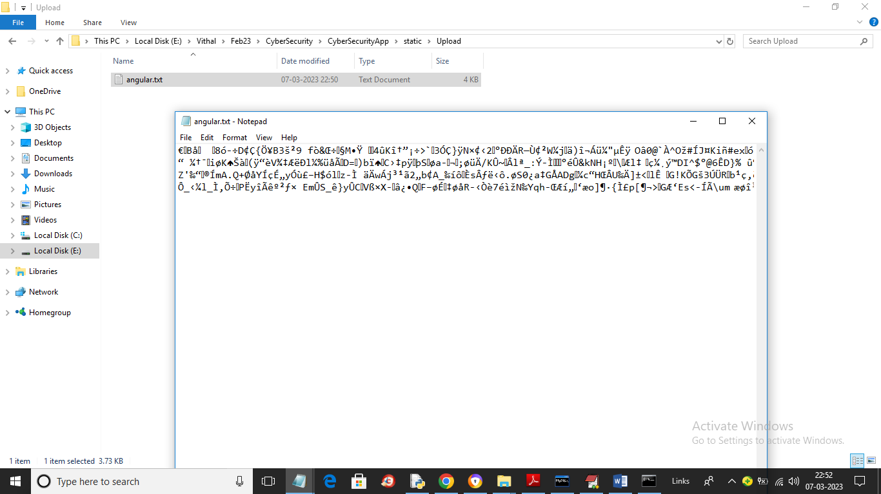
In above screen we can see file is saved at AV in encrypted format and now will upload image and you can upload any type of file
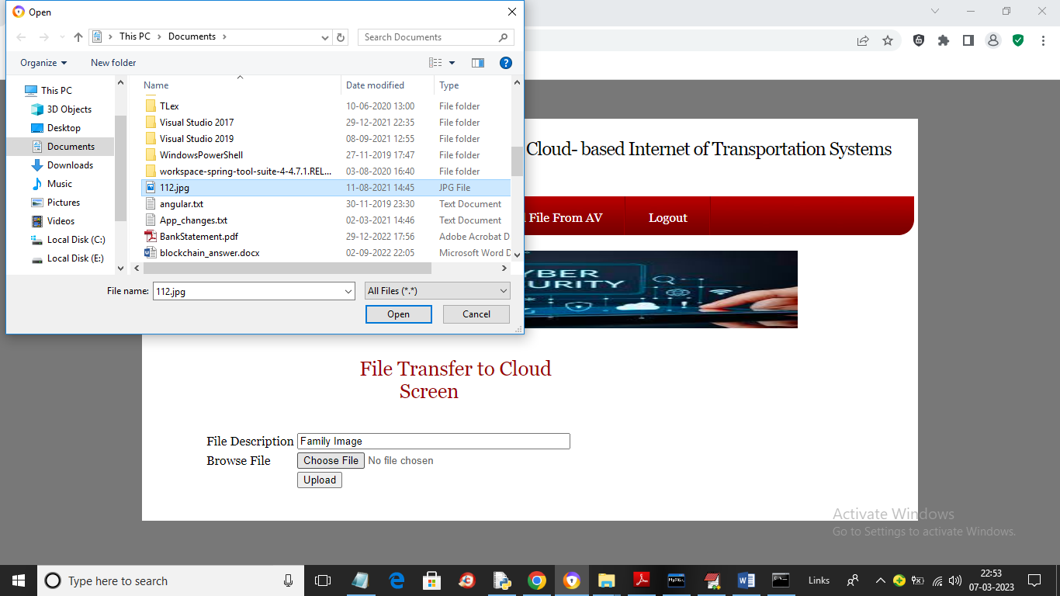
In above screen uploading image and then click on button to get below page
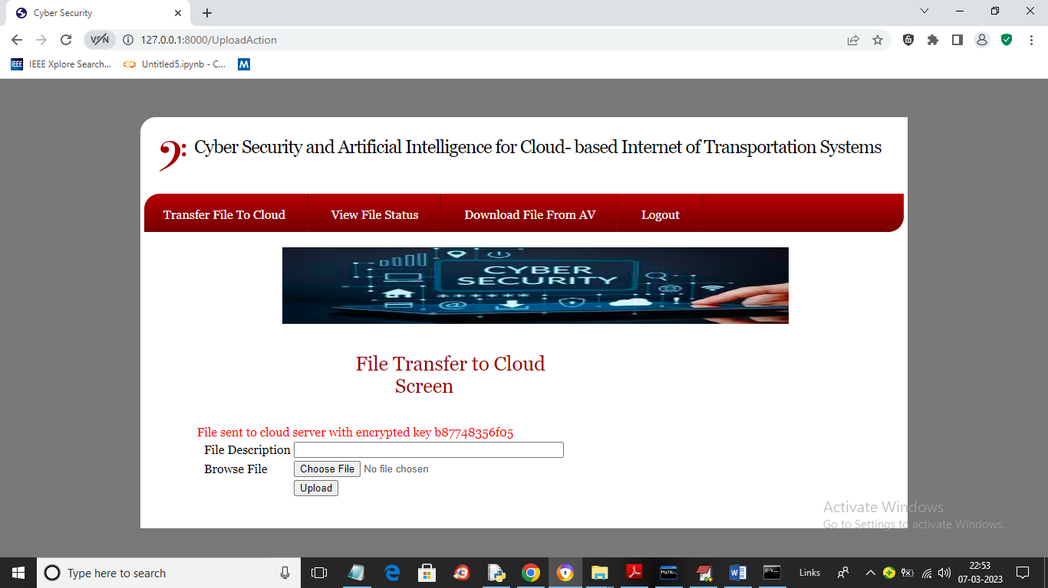
In above screen we can see image file also encrypted and saved at AV and now click on ‘View Status’ link to get updates from AV in below screen
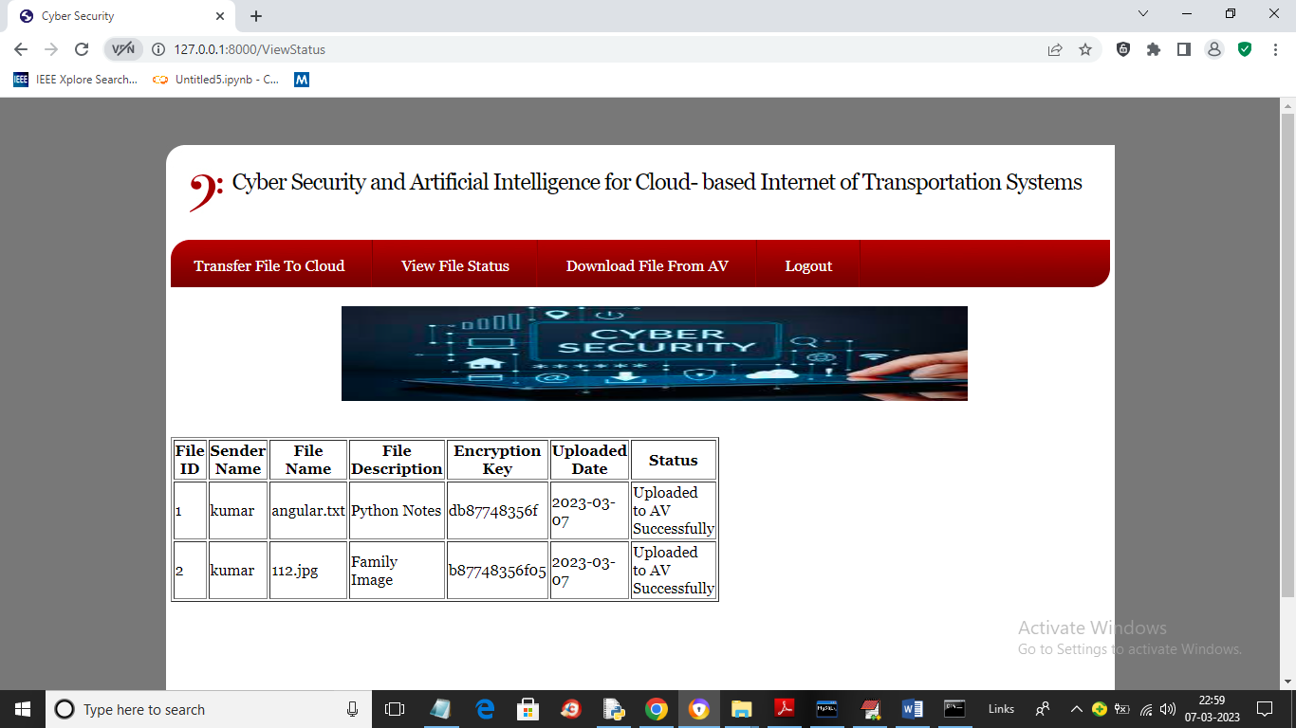
In above screen user can view list of uploaded file and updated message from AV and now click on ‘Download File from AV’ link to get below page
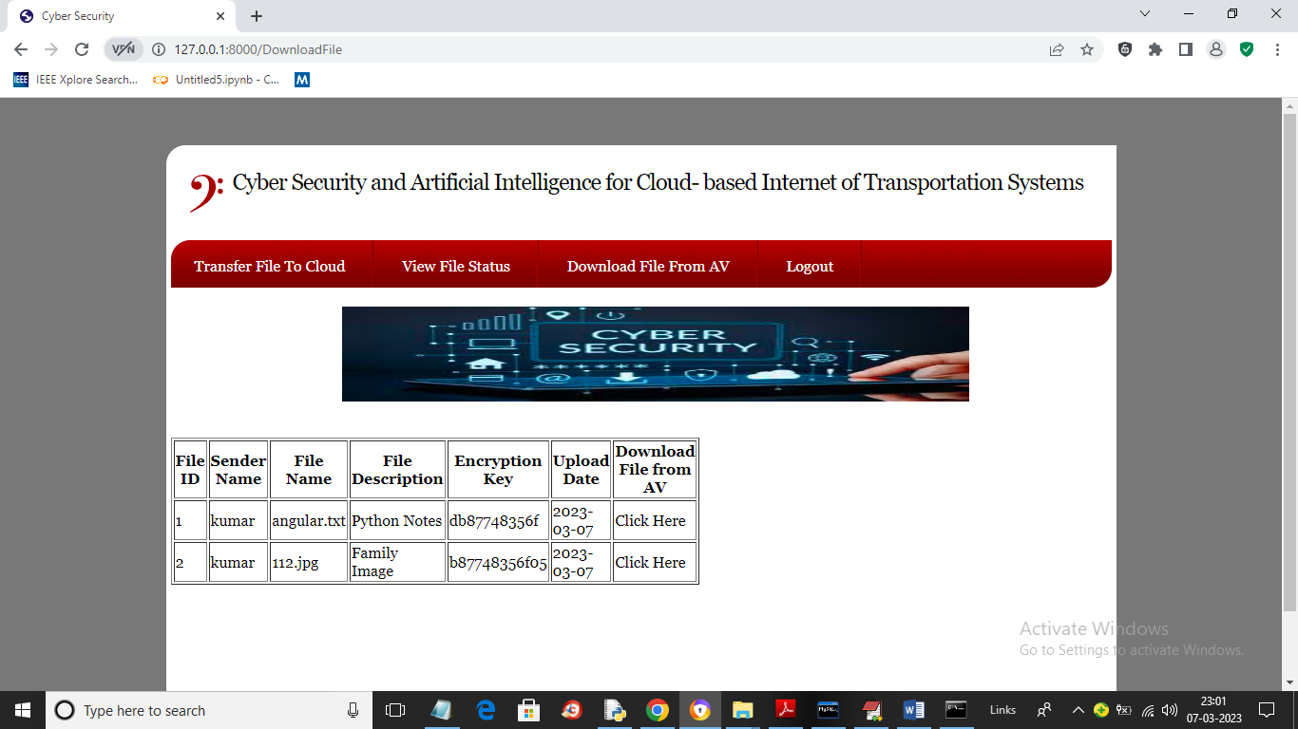
In above screen user can click on ‘Click Here’ link to download file in decrypted format and get below output
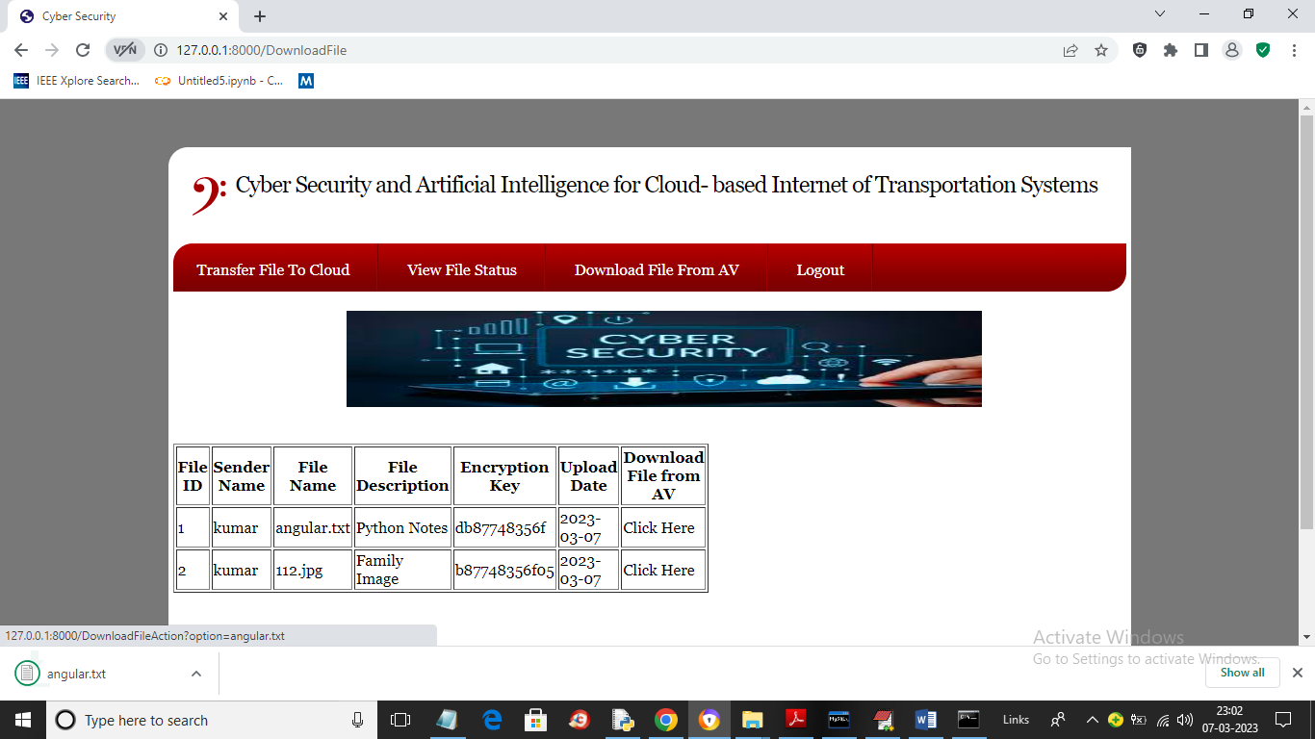
In above screen in browser status bar we can see file is downloaded and you can open and see that file and now logout and login as ‘AV’ using username and password as ‘admin’
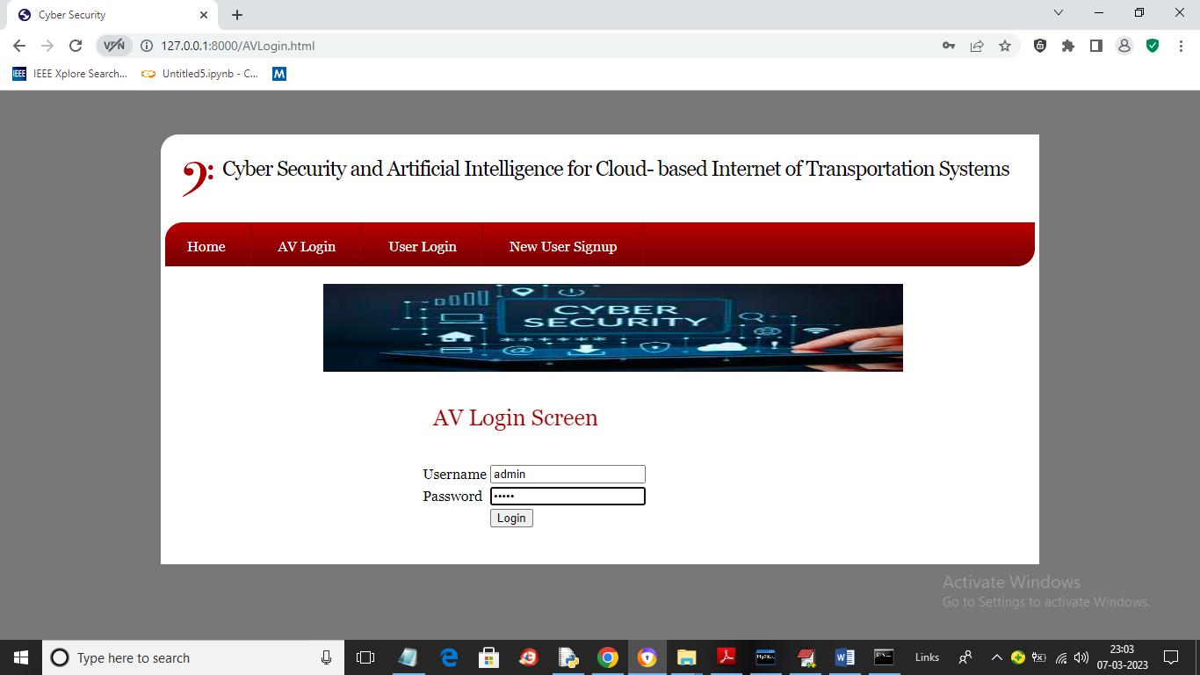
In above screen AV is login and after login will get below page
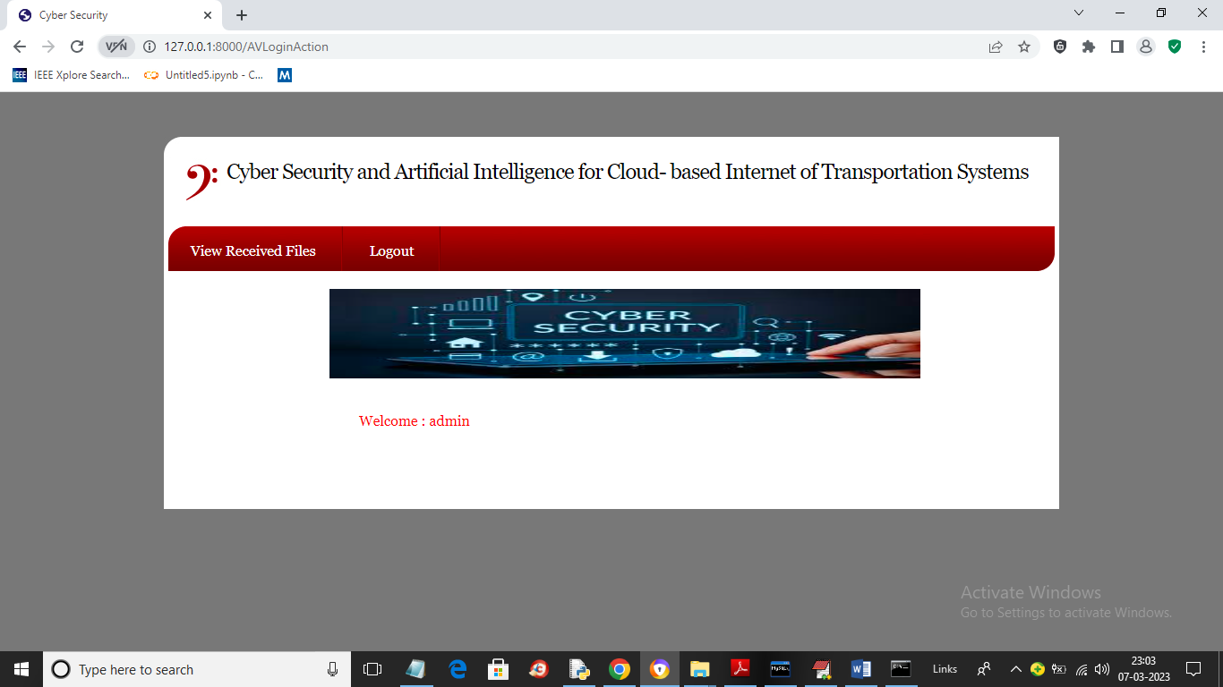
In above screen AV can click on ‘View Received Files’ link to get below pag
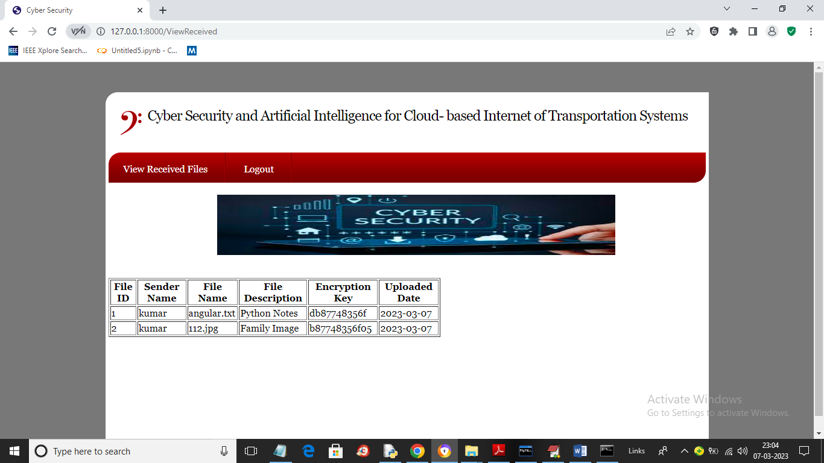
In above screen AV can view list of files uploaded by users and similarly you can upload and test any other file but don’t upload too big file as this server is for study purpose so its memory will be less

